

EE2111A elogbook

Duan Yihe



# W1S2

# Activity 1a I-V Characteristic of R/G/B LEDs

Limit supplied current: 1 A

Construct the circuit shown below:

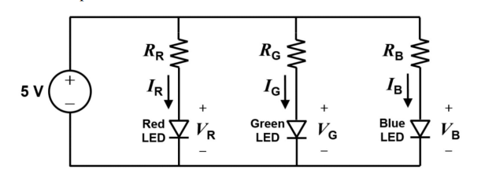

*Fig 1. LED Circuit Diagram*

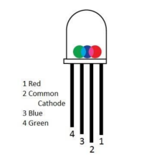

*Fig 2. LED Pin Layout*

**Notably, pin 1 is red positive, pin 2 is common negative, pin 3 is blue positive and lastly 4 is green positive.**

By varying resistances, tabulate the currents and voltages for each LED:

|  |  |  |  |  |  |  |
| --- | --- | --- | --- | --- | --- | --- |
|  | | Values for RR, RG, RB | | | | |
| Nominal Resistance | | 150 | 330 | 560 | 820 | 1500 |
| Measured Resistance | | 147 | 325 | 559 | 811 | 1486 |
| Red LED | Voltage VR | 2.02 | 1.91 | 1.86 | 1.83 | 1.78 |
| Current IR | 21 | 10 | 5.2 | 4.0 | 2.3 |
| Blue LED | Voltage VB | 3.09 | 2.93 | 2.84 | 2.80 | 2.72 |
| Current IB | 13.2 | 6.5 | 4.0 | 2.8 | 2.5 |
| Green LED | Voltage VG | 3.09 | 2.99 | 2.76 | 2.68 | 2.57 |
| Current IG | 13.2 | 6.7 | 4.2 | 3.0 | 1.7 |

For each of R,G and B LEDs, plot the I-V curves

Comparison between my graphs with those provided in the datasheet for the RGB LED lamp

# Activity 1b What’s the Mystery Colour

Try to change the resistors to get to designated mystery colour

A: pinkish

# Optional - Try to get White colour by varying the trimmers

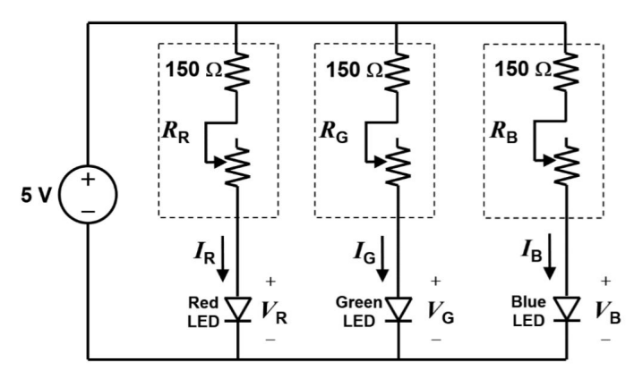

*Fig . Optional activity*

# W2S2

# Activity #1(a): Amplitude Measurement

Measure  
(i) the amplitude, and  
(ii) the peak-to-peak amplitude

# Activity #1(b): Effect of Coupling

rite down what you observe on screen when the offset is changed:  
(i) for DC coupling, and  
(ii) for AC coupling

# Activity #1(c): Time and Frequency Measurements

# • Measure the period and the frequency (Hz) of the sine wave. Compare the measured frequency with the one displayed in the signal generator.

# Activity #1(d): Effect of Trigger

# • In previous activities, CH1 was used as the source of trigger. Change the trigger source to CH2. Note down what you observe.

Change the trigger source back to CH1. Now, bring the trigger level above  
the maximum value of the waveform or below the minimum value by  
turning the trigger knob. Note down what you observe.

**Something about Trigger:**

**It has slope/ edge / falling slope/ rising slope for different electronic components**

**Trigger exists to tell the machine to ‘stop’ and ‘capture’ the moment so that a clearer picture of a periodic waveform.**

**If a signal is noisy, consider using ‘Normal’ or ‘Single’ rather than ‘Auto’**

Activity #1(e): Phase Shift Measurement  
• Use the components given to patch up a series RC circuit on the bread-  
board.  
• Apply a 1 kHz sine wave generated by the signal generator across the  
series R and C.  
• Observe this signal in CH1 and the voltage across the capacitor in CH2.  
• Measure  
(a) the period, and  
(b) the time-axis offset between the two sine waves.  
Then compute the phase-shift between the two waveforms. Note down the  
values of period and phase shift.

**Phase difference calculation:**

# Activity #1(f): Current Measurement

• Measure the amplitude of the current in the RC circuit you patched up, and  
note it down.  
• Measure the phase-shift of the current with respect to the input voltage,  
and note it down.

Note: • Measure the amplitude of the current in the RC circuit you patched up, and  
note it down.  
• Measure the phase-shift of the current with respect to the input voltage,  
and note it down.

# Week 3

## W3S1

CircuitLab Exercise #1 - Frequency dependence of response  
The response of ac circuit containing energy-storing component(s) varies if  
the frequency is varied. In this activity, you will verify that through Circuit-  
Lab simulation.  
1. Use the RC circuit given in Fig.1, taking R=100 Ω and C=10 μF. Take  
source voltage as a sine wave of amplitude of 10 and frequency of 1000Hz.  
2. Simulate with a few different frequencies, e.g., **500 Hz, 1 kHz, and 2 kHz**  
to observe **capacitor voltage vc(t**). For each case, determine the values of  
**amplitude A and phase shift φ** of capacitor voltage.  
3. **Plot amplitude versus frequency** and **phase shift versus frequency**.  
(OPTIONAL)  
Repeat this experiment **with 0.1 H inductor in place of the 10 μF capacitor**.

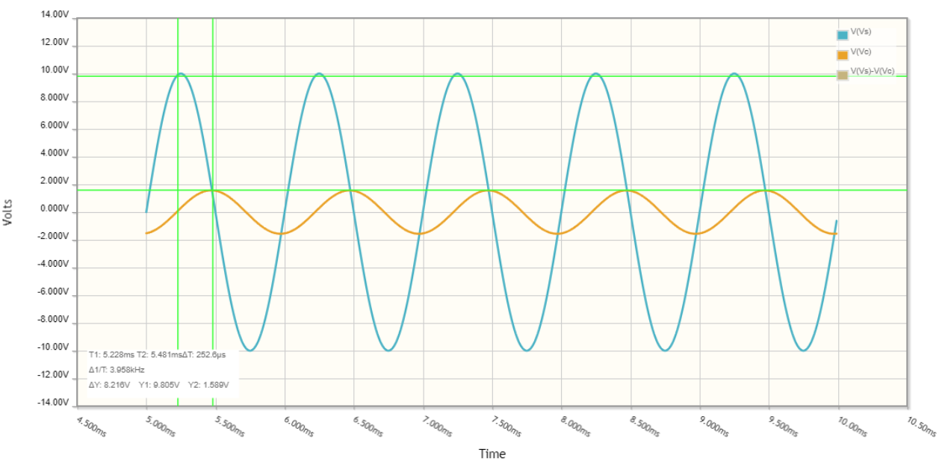

1000 Hz

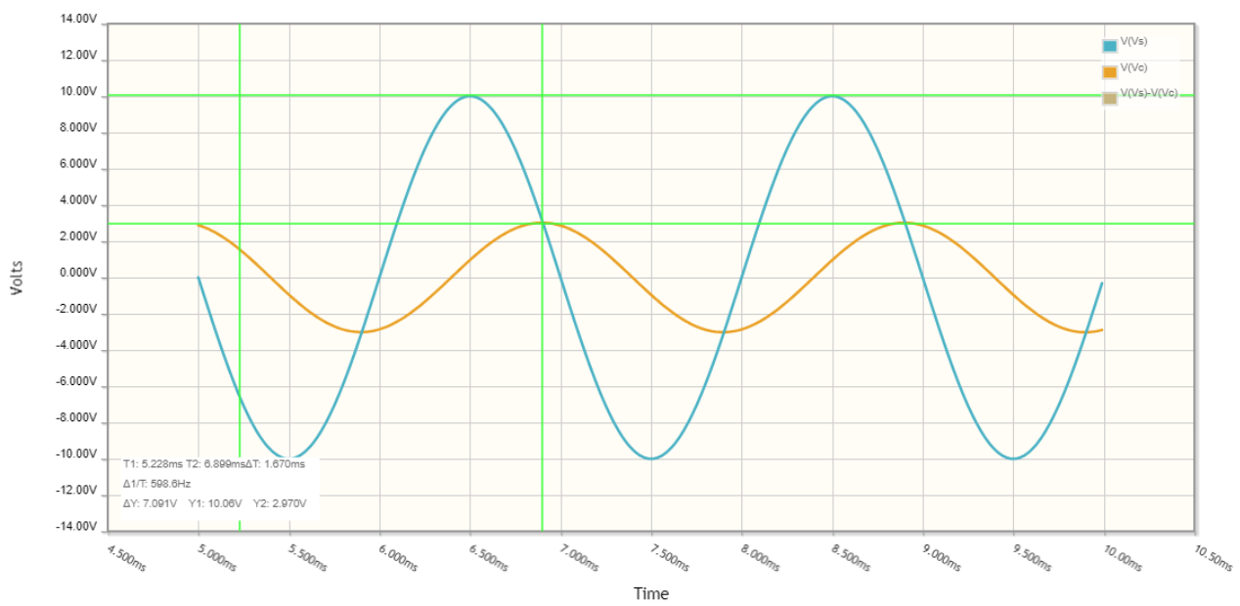

500 Hz

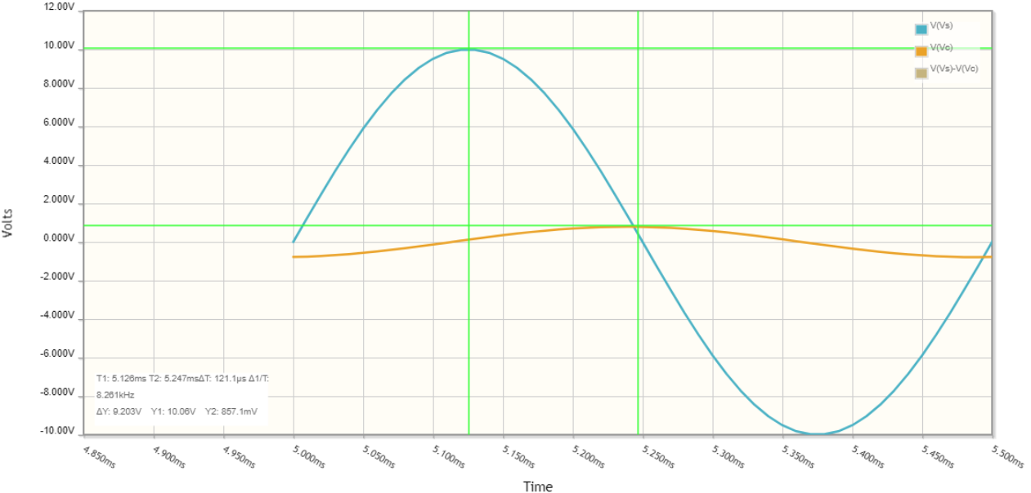

2000 Hz

CircuitLab Exercise #2 - RLC circuit  
The response of an AC circuit to the applied **voltage** depends on the **frequency of the source voltage**. The same circuit will draw **different magnitude  
of current** if the **source frequency is changed** though the source amplitude  
is kept fixed.

vS(t) = A sin(ωmt), m = 1, 2, 3, · · ·

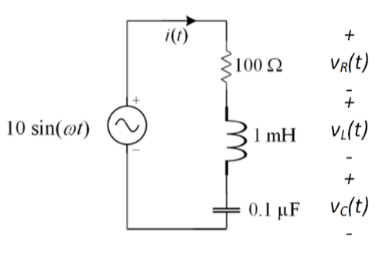

Observation:

## W3S2

*about oscilloscope

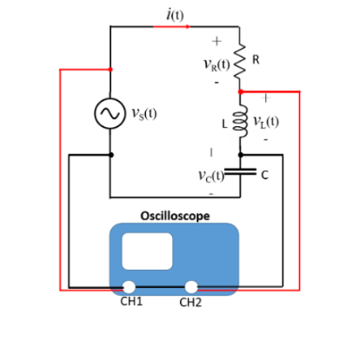

Activity #1: Phase shift between voltage and current

uild the circuit shown above on the breadboard with 120 Ω resistor in  
place of the rectangular box.

Steps:

i Measure the amplitude of the input **voltage**,  
ii Measure the amplitude of the voltage across the 100 Ω resistor & then  
calculate the amplitude of the **current** waveform, and  
iii Measure the **phase-shift** of v100 Ω **with respect to the input voltage**.  
This is effectively the phase-shift of current with respect to the input  
voltage.

repeat these measurements for  
a 1 mH inductor, and  
b 0.1 μF capacitor

|  |  |  |  |
| --- | --- | --- | --- |
|  | R-R circuit | R-C circuit | C-R circuit |
| Amplitude of Vs | 4.60 | 4.90 | 4.16 |
| Amplitude of V100ohms | 2.06 | 2.50 | 3.00 |
| Amplitude of i(t) | 0.0206 | 0.0250 | 0.0300 |
| Phase of *i* w.r.t Vs | 0 | 14us (0.877 rad) | 6.4us (0.405rad) |
| Current leads or lags? | 0 | Leads | lags |

Activity #2: Frequency dependence of AC circuit

1. Patch up a series RLC circuit on the breadboard using R = 100 Ω, L = 1  
   mH, and C = 0.1 μF.  
   2. Calculate the resonant frequency ωr. (1/(LC)^1/2) = 100000 rad/s  
   3. Use the signal generator to apply a sinusoidal signal across the series  
   RLC. (15.92k)  
   4. Keeping the **amplitude** of the **signal generator output unchanged**, **vary its  
   frequency.**5. Measure the **amplitude** and **phase-shift** of the **current** at **each frequency**.  
   Take measurements at ωr, few frequencies lower than ωr, and a few  
   frequencies higher than ωr.  
   6. Plot using **Excel** or any other software a graph of the **amplitude** of the  
   current as a function of frequency.

Reflections:  
• Can you calculate value of ωr for the series RLC circuit? Yes.  
• Explain the **difference** between the ωr obtained from the graph and the  
calculated value.  
• Describe the **variation of amplitude** of current with frequency.  
• Describe the **variation of the current phase-shift** with source frequency.  
• For **frequencies below the resonance frequency**, is the current **leading** or  
**lagging** source voltage?  
• For frequencies **above the resonance frequency**, is the current **leading** or  
**lagging** source voltage?  
• Can we say that the RLC circuit behaves like R-L or R-C circuit depending on whether the source frequency is above or below the resonance frequency?  
• Does **RLC circuit** behave like a **resistive circuit** at **resonance frequency**?

## W4S1

Phasor: phase vector

## W5S2

Learning Objectives  
To be able  
• to measure voltage and current in AC circuits using oscilloscope  
• to find phasor representation of sinusoidal signals  
• to verify KVL in AC circuits using voltage phasors  
• to verify KCL in AC circuits using current phasors

Activity #1: Verify KVL in a series RLC circuit

While keeping vS(t) connected to CH1, observe the voltages vC (t),  
vL(t), and vR(t), **one at a time in CH2**, and measure the amplitude of the  
waveform and its phase-shift with respect to vS(t).

Reflections:  
Record the following:  
• Observe plots of source voltage and the three individual R, L and C volt-  
ages.  
• Write the time-domain expressions of vS(t), vR(t), vL(t), and vC (t)  
• Did you learn how to determine the phasors for the various voltages measured?  
• Did you try KVL equation using the voltage amplitudes only?  
• Did you note that KVL holds only for voltage phasors and not for amplitudes alone?

Activity #2 Verify KCL in a series RLC circuit

Reflections:  
• Did you note how currents can be measured in Oscilloscope?  
• Will KCL hold with the three current amplitudes only?  
• Did you note that KCL in AC circuits should be written using branch  
current phasors?  
• Draw the phasor diagram showing the branch currents and the source  
current to show their relative phases.

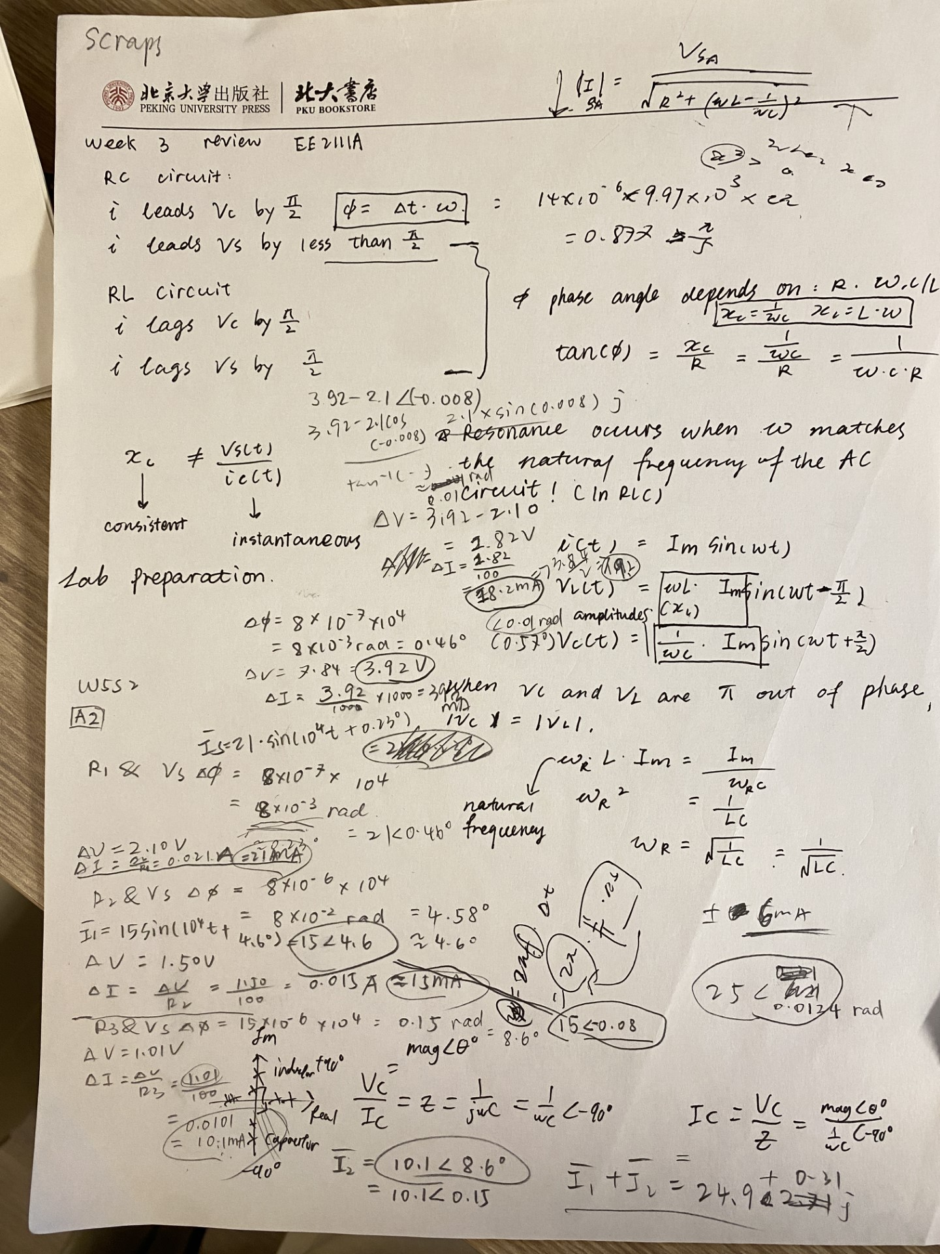

Notes:

Use channel 1 to measure Vs

Phase difference = 2 pi f delta t

When I have a resonating RLC circuit, not just the C and L can be resonating, the resistor in the big branch is also resonating. ( pure resistor circuit)

Attenuation effectiveness

The gradient (roll off) is fixed in the bode curve (-20 dB / dec)

W6S2

Activity : Design a filter as per given specifications, using available  
components

*Filter 1 - Band-Width Filter*

1. Given the materials you have, design a filter circuit that will allow frequencies above 10 kHz to pass through, but frequencies below 1 kHz to be attenuated (at least by 6 dB).

2. Carryout Frequency-domain simulation of the filter in CircuitLab to checkif the frequency response meets the design requirement.

3. Build the circuit on a breadboard.

4. Test the circuit by giving it an input from the signal generator, and measuring the input and output on the oscilloscope.

5. Tabulate the frequency response (in dB) at 100 Hz, 500 Hz, 1 kHz, 2 kHz,5 kHz, 10 kHz, 20 kHz, 50 kHz, and 100 kHz. Plot/sketch the frequency  
response.

Cut-off frequency for low pass =

*Filter #2*  
1. Given the materials you have, design a filter circuit that will allow frequencies below 10 kHz to pass through, but frequencies above 100 kHz to be attenuated (at least by 6 dB).

2. Carryout Frequency-domain simulation of the filter in CircuitLab to checkif the frequency response meets the design requirement.

3. Build the circuit on a breadboard.

4. Test the circuit by giving it an input from the signal generator, and measuring the input and output on the oscilloscope.

5. Tabulate the frequency response (in dB) at 1 kHz, 5 kHz, 10 kHz, 20kHz, 50 kHz, 100 kHz, 200 kHz and 500 kHz. Plot/sketch the frequency  
response.

Reflections  
1. Are you able to draw the circuit diagram for the filter, labeling the values  
of all components?  
2. Did you learn the calculations/explanation of how the values of the com-  
ponents were chosen?  
3. Do you know how to carryout Frequency-domain simulation of the filter  
in CircuitLab to check if the frequency response meets the design requirement?  
4. Did the tabulated frequency response match the design? Are you able to  
explain any discrepancy?

Digital Filter: Decipher a Secret Message

The filters that you have designed, implemented, and tested so far are ana-

log filters. It is also possible to realize a filter digitally. This form of more

powerful and versatile filter implementation is called digital filter. In this

fun activity, you will see an example of digital filter designed to decipher a

human voice embedded in a jamming signal.

As you may not have adequate background knowledge that is required

to understand the theoretical concepts behind the implementation of

digital filters, this activity will not go in-depth. Rather, you will use freely

available codes to realize a filter to decipher the audio signal.

The process of designing a digital filter is given as a set of guided in-

structions in the file Digital Filter - Decipher a Secret Message. Follow

the instructions given there to recover the human voice from the noisy audio

signal in secretmsg.wav.

1. Identify the constituent frequencies of the audio signal,  
   (b) Determine the range of frequencies that must be filtered out, and  
   (c) Design a filter with the required cut-off frequencies to filter out the jamming noise

Power Spectral Density (**PSD**) is a widely used method of describing the  
intensity distribution as function of frequency.

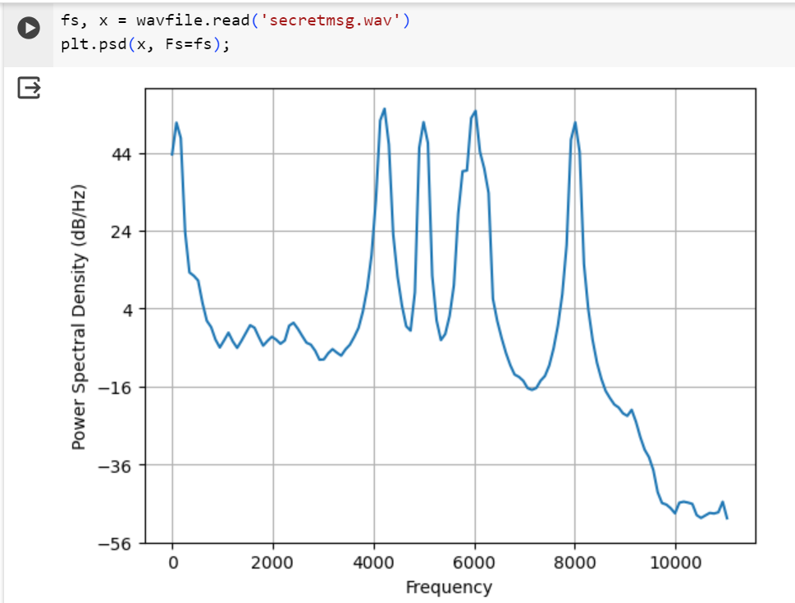

Week 7

PMDC Motors:

F = BLI sinx

FW = Torque

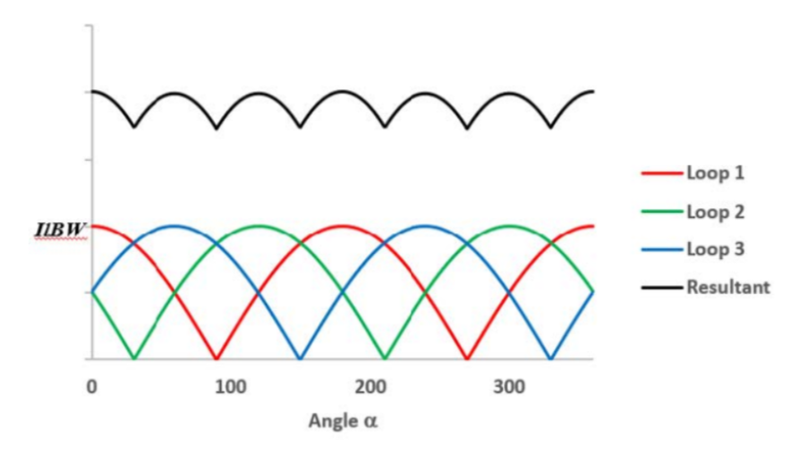

Imagine countless of coils, the ripples are flattened.

*Tem = n(BLI)W*

*Tem = Kt Ia*

*Ia is rotor current* or *armature current*

*The armature is an inductor as it is literally a bunch of coils, so the change of current is not instantaneous.*

*te = L/R*

Friction

Back EMF creates a friction torque

*Tnet = Tem - Tf*

*Tf = Kf w*

Approaching steady state, motor is not loaded,

*Tem = Tf*

*Tnet = 0*

*Wss  = Tf / Kf = Tem / Kf*

Kf is friction constant

The induced back EMF also causes a “back current”, that reduces the overall current flows in the coil.

When I is reduced, F is also reduced, hence the acceleration of armature is reduced.

W8S2

Activity 1a)

Vmax = 14.2V Vrms = 9.88V

Activity 1b)

Vmax = 12.3V Vmin = 0V Vpp = 12.3V Vavg = 6.99V

Activity 1c)

Vmax = 12.6V Vmin = 12.4 V Vpp = 0.2V Vavg = 12.4V